Network Routing

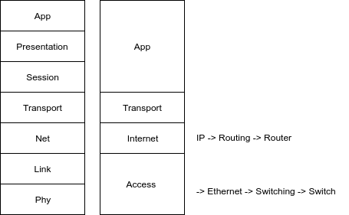

A router has 4 types of memory :

* ROM -> to make a boot
* NVRAM
* RAM : running configuration
* Flash (IOS)